**Comprehensive Analysis of Tree Data in Camden**

**Visualization 1:** **Tree Height Over Time**

The line plot serves the purpose of visualizing how the height of different tree species changes over time. Tree heights are increasing with time, from 2008 when they had a height below 10 meters. In 2020, trees are tall to a height of 40 meters. Those that were growing at a fast rate.

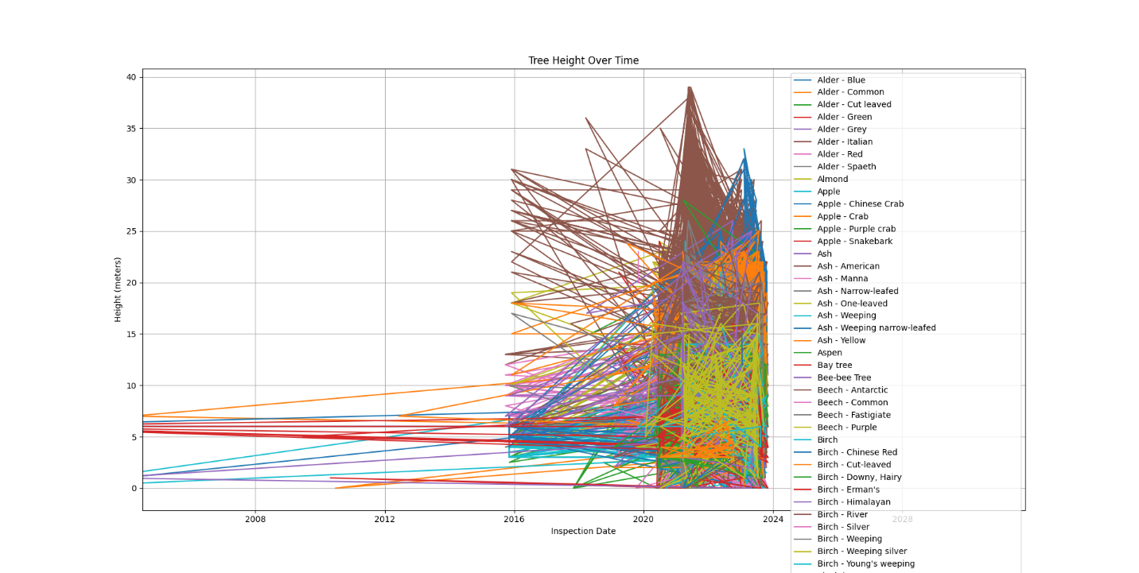

**Visualization 2:** **Diameter vs. Carbon Storage**

This scatter plot visualizes the relationship between tree diameter and carbon storage for each tree. The smaller the tree's diameter, the less the carbon storage, but as the trees increase in diameter, the more the carbon storage. Trees with huge diameters are reducing in amount while trees with small diameters are so many.

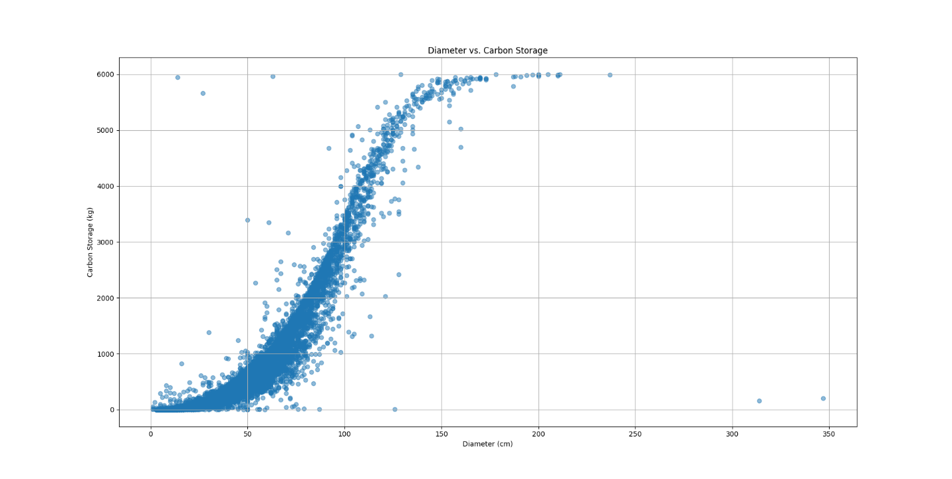

**Visualization 3:** **Distribution of Tree Heights**

The histogram displays the distribution of tree heights within the dataset. It helps you understand how the heights of trees are distributed and provides insights into the most common height ranges. Trees with a height of 5 meters are more available; this distribution reduces to a height of around 15 meters, where it increases again, and then the frequency reduces as the height increases.

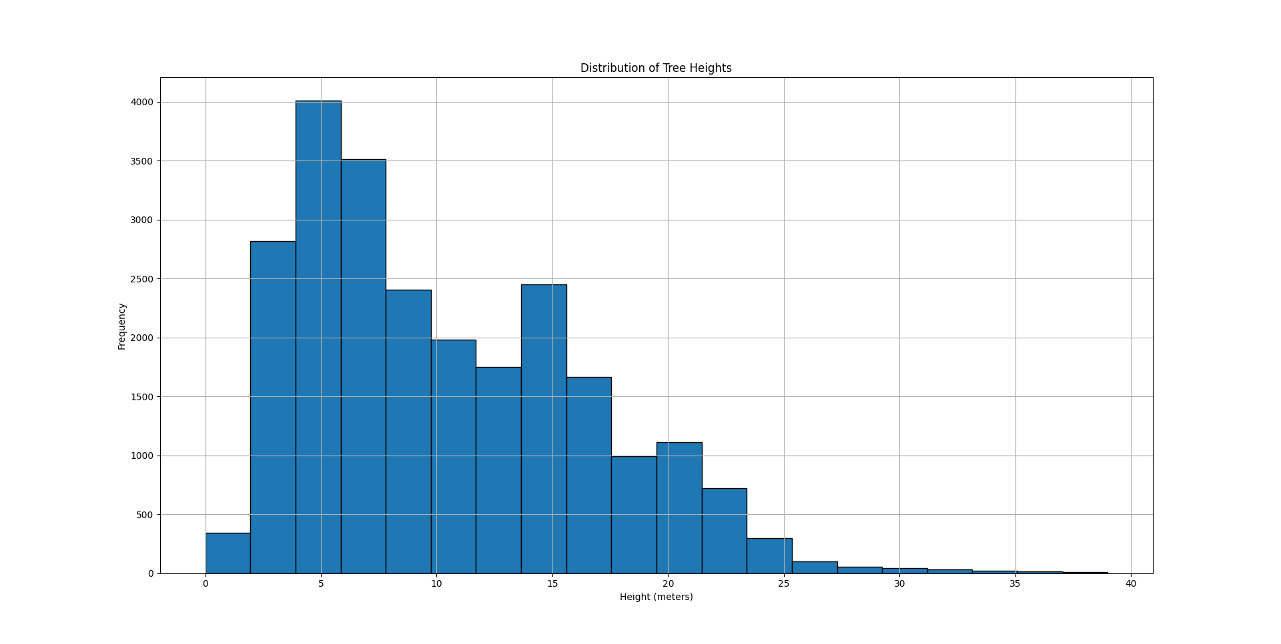

# References

<https://ckan.publishing.service.gov.uk/dataset/trees-in-camden/resource/90f54a10-356c-453f-a7dc-9bd80ae6b564>